4th Down Decision System
User Guide

1. Overview of the Application
The 4th Down Decision Assistant is a tool that helps football coaches or analysts decide what to do on 4th down. Instead of relying on gut feeling or tradition, the app uses historical NFL play data (2020–2025) to estimate the odds of success for each available choice and recommends the option most likely to help your team win.
The app answers three related questions for any 4th-down situation:
- If we run or pass, how likely are we to convert and get a new set of downs?
- Between going for it, kicking a field goal, or punting, which choice gives us the best chance of winning the game, not just this one play?
- Looking ahead at an entire drive, roughly where on the field does the “right” decision change from punting, to going for it, to kicking?
Who it's for:
- Coaches and coordinators who want a data based second opinion on 4th down calls, either in the moment or while planning a drive beforehand.
Can also be used by:
- Football analysts and content creators who want to explore how field position, score, and time affect the 4th down decision.
- Fans who want to understand why analytics minded broadcasters and coaches increasingly favor “going for it” in situations that once called for a punt or kick.

2. Page Navigation
The app has two pages, or “tabs” shown along the top of the screen. In Game Decision Maker and Pre-Drive Planner. Each tab is a unique purpose tool. You don't need to visit them in any order.

2.1 In Game Decision Maker
Use this tab when you're facing a specific 4th down right now and need an immediate recommendation.

Inputs (left hand panel)
- Yards to Go - how many yards are needed for a first down.
- Ball Location - choose “Own territory” or “Opponent territory,” then set the Yard Line slider (1-50). Together these describe exactly where the ball is, the same way you'd read it off a scoreboard (for example, “Own 37” or “Opponent 22”). A confirmation line under the slider (“Ball on: OWN 37”) shows you exactly what you've selected. If the ball is on the 50, enter 50 and “Own territory” or “Opponent territory” will work the same.
- Score Differential - your team's score minus the opponent's (negative if trailing): for example, leading by 3 is “3” and trailing by 3 is “-3”.
- Quarter, Minutes Remaining in Quarter, Seconds Remaining - the current game clock.
- Point Spread - the pregame point spread for your team; enter a positive number if your team was favored, negative if you were the underdog. If you don't know it or don't want to use it, leave this at 0.

Outputs (right hand panel)
- Recommendation - a plain language summary: the single best decision (Go for it / Field Goal / Punt) and, if going for it is best, whether a run or a pass gives the better odds.
- Run vs. Pass Conversion Probability (table) - the estimated percentage chance of converting the 4th down with a run versus a pass.
- Win Probability by Decision (table) - the estimated chance of winning the game under each of the three choices, ranked highest to lowest.
- Conversion Probability by Distance (chart) - a line chart showing how the run and pass conversion odds change across a range of distances (1 to 15 yards to go), with a dashed vertical line marking your current situation for context.

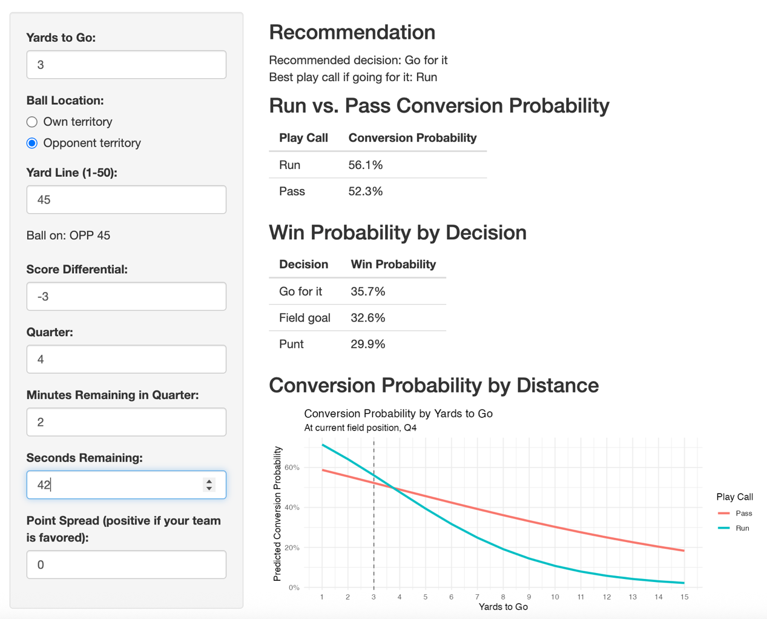
Figure 1. The In-Game Decision Maker tab.

2.2 Pre-Drive Planner
Use this tab before a drive begins, when you want a general sense of how the recommended decision should change as your team moves down the field without knowing the exact distance yet.

Inputs (left hand panel)
- Score Differential, Quarter, Minutes Remaining, Seconds Remaining, Point Spread - same meaning as on the In-Game Decision Maker tab.
Field position and distance are not entered here - instead, the chart and summary automatically show the recommendation across the entire field, for three standard distances (Short, Medium, Long).

Outputs (right hand panel)
- Win Probability by Decision and Distance (chart) - three side by side panels (Short: 4th & 1–3, Medium: 4th & 4–6, Long: 4th & 7+), each plotting the win probability of Going for it, kicking a Field Goal, or Punting, across every yard line on the field.
- Drive Plan Summary (text) - underneath the chart, a plain-language breakdown for each distance bucket, written in scoreboard terms, such as “Before your 39 → Punt” or “Opponent's 44 and closer → Field Goal.” This tells you roughly where the recommended decision changes as your team crosses the field.
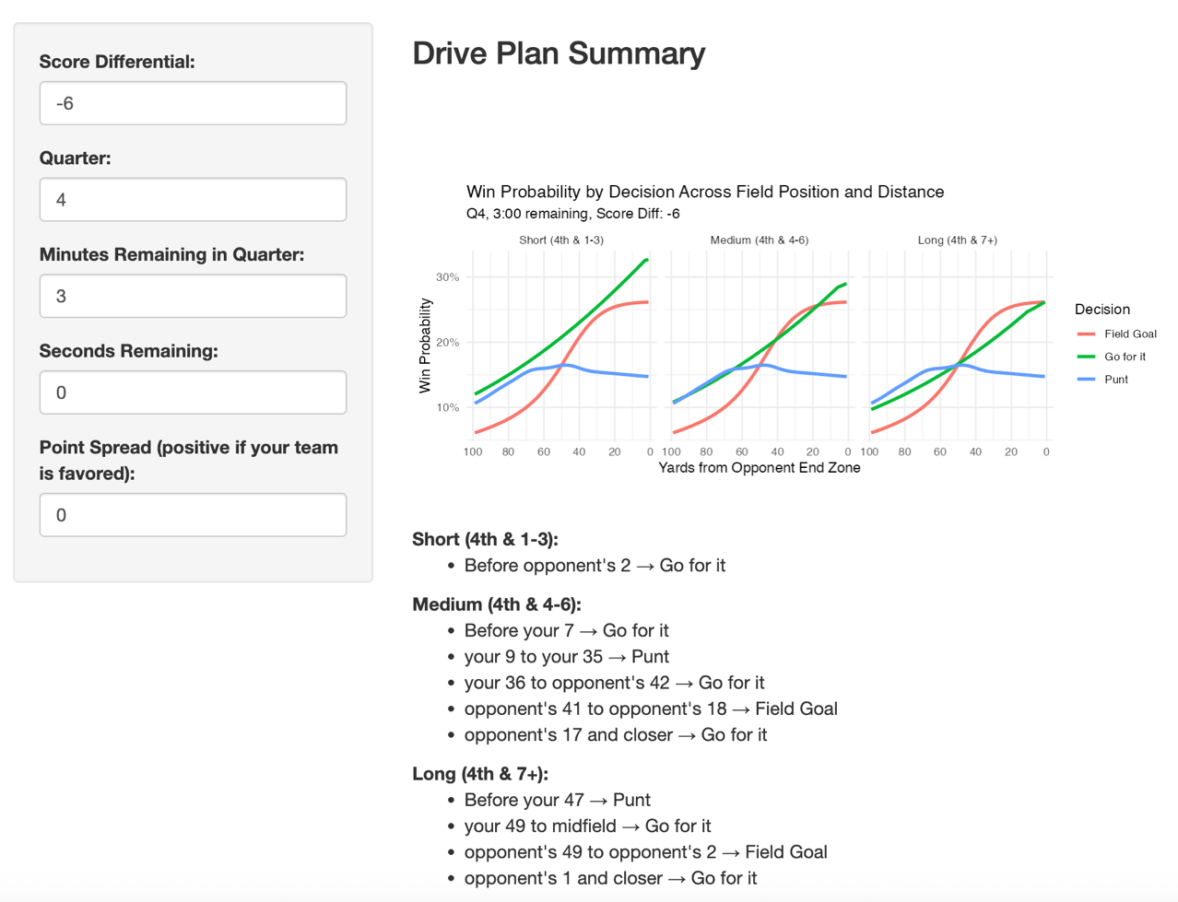
Figure 2. The Pre-Drive Planner tab, showing the chart and the Drive Plan Summary.

3. Use Case Walkthroughs

Scenario 1: Making an In-Game 4th down Call
Your team is facing 4th and 2 from the opponent's 38 yard line. It's the 3rd quarter, 5 minutes and 30 seconds remaining, and you're trailing by 3 points.
- Click the In Game Decision Maker tab.
- Set Yards to Go to 2.
- Select “Opponent territory” and set the Yard Line slider to 38.
- Set Score Differential to -3 (trailing by 3).
- Set Quarter to 3, Minutes Remaining to 5, Seconds Remaining to 30.
- Leave Point Spread at 0 unless you know your team's pregame spread.
- Read the Recommendation at the top of the right hand panel, then check the two tables underneath for the exact percentages behind that recommendation.
What you'll see: the app will tell you which of the three choices gives your team the best odds of winning from this exact spot, along with the run vs pass breakdown if going for it is the better play.

Scenario 2: Planning Ahead for a Drive
You want a general feel for how aggressive to be during an upcoming drive, trailing by 6 points late in the 4th quarter, without knowing yet exactly what down-and-distance you'll face.
- Click the Pre-Drive Planner tab.
- Set Score Differential to -6.
- Set Quarter to 4, Minutes Remaining to 2, Seconds Remaining to 0.
- Leave Point Spread at 0 unless you know it.
- Look at the three chart panels (Short, Medium, Long) to see how the Go for it, Field Goal, and Punt lines compare across the whole field.
- Read the Drive Plan Summary underneath the chart for a plain-language version of the same information, broken out by distance.
What you'll see: trailing by 6 with little time left, the app generally favors kicking a field goal once you're within realistic range. 3 points alone don't win the game while still keeping the door open to going for it in short yardage spots.
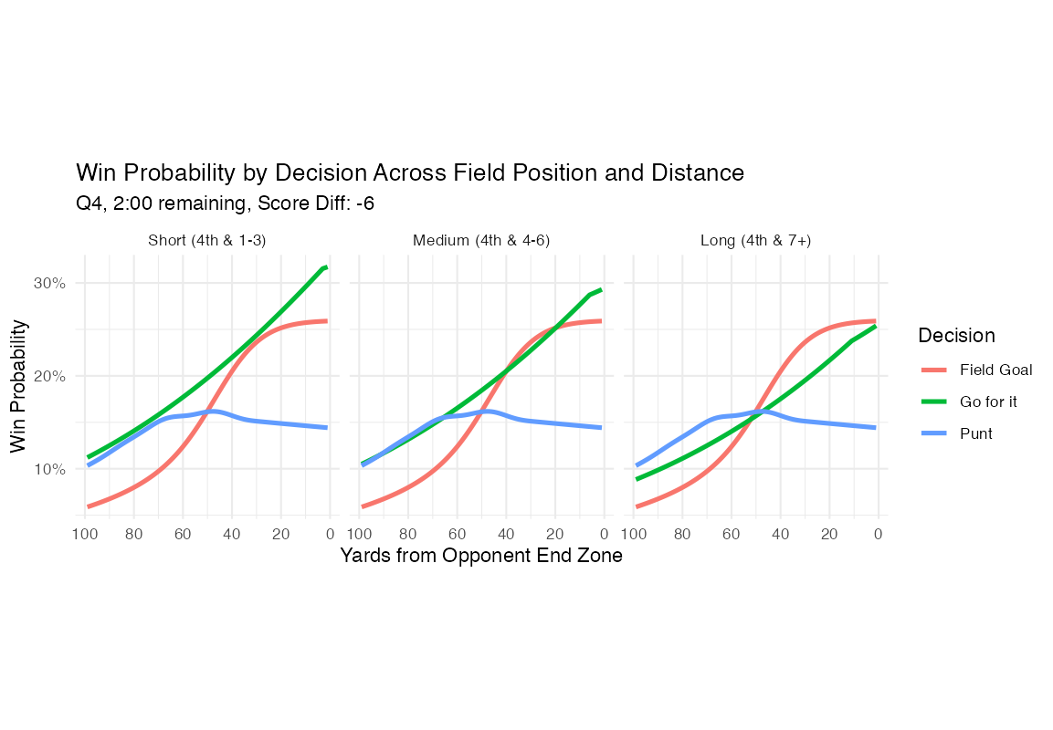
Figure 3. Pre-Drive Planner output for a team trailing by 6, late in the 4th quarter.

Scenario 3: Midfield run or pass decision
Your team was a 4 point underdog heading into the game. You are at midfield 4th and 3 with 3:32 to go in a tie game. Your instinct is to go for it but cannot decide whether to run or pass.
- Click the In Game Decision Maker tab.
- Set Yards to Go to 3.
- Select “Own territory” or “Opponent territory” and set the Yard Line slider to 50 (midfield either selection gives the same result at exactly the 50).
- Set Score Differential to 0 (tie game).
- Set Quarter to 4, Minutes Remaining to 3, Seconds Remaining to 32.
- Set Point Spread to -4, since your team was a four point underdog.
- Look whether run or pass has a higher percentage in the Recommendation or which line is higher in the Win Probability by Decision table.
What you'll see: the recommended decision may not change, but the underlying win-probability percentages will shift — being the favored team generally raises your estimated win probability across all three options, reflecting that a stronger team is more likely to win from any given situation.

4. Common Questions & Troubleshooting
Issue / Question | Answer
The app is showing a Field Position readout that doesn't match what I expected. | Double check your inputs, like which radio button is selected. “Own territory” and “Opponent territory” use the same 1-50 input but represent opposite sides of the field. The “Ball on: …” line underneath the slider always shows exactly what the app has registered, so use it to confirm before reading the recommendation.
I don't know my team's point spread. What should I enter? | Leave Point Spread at 0. The app will still produce a recommendation. Then it simply won't factor in whether your team was considered stronger or weaker than the opponent going into the game.
Why does the recommendation differ between the In Game Decision Maker and the Pre-Drive Planner for what looks like a similar situation? | The Pre-Drive Planner shows three standard representative distances (Short, Medium, Long) rather than your exact yards to go, so it's meant for general planning, not a specific play. These buckets summarize the continuous model into coach-friendly ranges to remember. For an exact situation, always use the In Game Decision Maker.
The recommendation seems to favor “Go for it” very often. Is that a bug? | Not necessarily, modern NFL analytics have shown that teams historically punt and kick field goals more often than the numbers justify, especially on 4th and short. The app is built historic play by play data so a recommendation to go for it, even in situations that feel unconventional, reflects a data backed difference rather than an error. Coaches should still apply personal judgement in play calls.
Can I trust the exact percentages, or just the overall recommendation? | Treat the percentages as informed estimates rather than guarantees, they're built from several years of real NFL play data, but no model can perfectly predict a single game. The relative comparison between the three decisions (which one is highest) is generally more reliable than treating any single percentage as exact.
The charts or tables show errors, look empty or aren't updating. | First make sure that no input fields are empty. Try adjusting any input slightly (for example, nudge the Yard Line slider by one) to force the page to refresh. If the issue persists, reload the page in your browser.
How can I reduce the input time in the games? | Not every input needs to be set every time. Set the spread once before the game. Update the quarter input in the break at the start of each quarter. Update the score differential before each drive. This will reduce the number of inputs needed between the end of the 3rd down play and 4th down play call.

