The objective of this project was to create a win probability model capable of estimating the likelihood of winning a game based on information about the game situation. The model is estimating the probability that the team in possession wins at a given point in the game, based on the game state before each play occurs.
Play-by-play data from the NFL was collected using the nflfastR package. The dataset included games from the 2020–2025 NFL seasons. Each row represented an individual play and contained information about the game situation, including down, distance, field position, time remaining, and score differential. This was filtered down to remove plays with missing down, yards to go, yard line, time remaining or score differential. The training dataset included 179,880 plays.
A logistic regression model was utilized initially because the goal was not only to predict game outcomes, but also to see how different game situations influence win probability. Logistic regression estimates the probability of winning based on a set of independent variables which allows the impact of each variable to be interpreted. The initial model included the variables down, distance to go, yard line, time remaining in seconds, and point differential. The final game score variables included in the nflfastR dataset were used to create a binary dependent variable that measured if the team in possession was the winning team. In the initial model the seconds remaining variable was statistically insignificant with a p-value of .589. So, an interaction term between score differential and remaining time was added to better estimate the value of a lead throughout the game. For example, a seven-point lead early in the first quarter provides a much smaller advantage than a seven-point lead with two minutes remaining so logically the time remaining should be a significant variable.
The formula for the logistic regression was Win Probability= f (Down, Distance to go, Field Position, Time, Score Differential, Score Differential × Time)
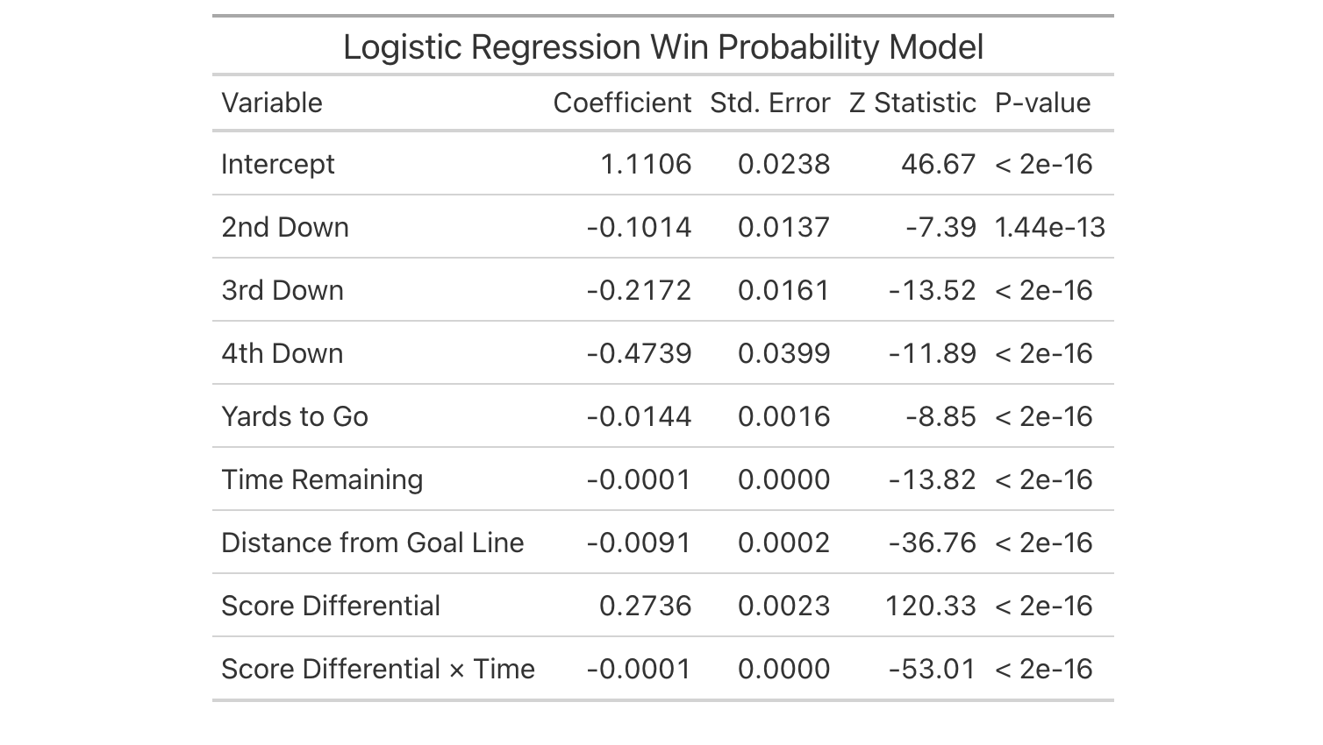
Table 1: Logistic Model Summary
The logistic regression coefficients indicate how different game situations influence the probability of winning. Because the model estimates the probability of winning, positive coefficients increase the likelihood of victory, while negative coefficients decrease the likelihood of victory. The strongest predictor in the model was score differential. The positive coefficient for score differential (β = 0.274) indicates that teams leading in the game have a higher probability of winning. However, the interaction between score differential and time remaining (β = -0.000061) shows that the importance of the score differential changes throughout the game. A lead early in the game has less impact than the same lead late in the game. Down, distance, field position, and time remaining were also significant predictors of win probability. Later downs were associated with lower win probabilities, with fourth down having the largest negative effect (β = -0.474) due to the increased difficulty of extending drives. Greater yards to gain decreased win probability, while better field position increased win probability. Time remaining was most meaningful when considered with score differential, as the value of a lead changes throughout the game.
Model performance was evaluated using the area under the receiver operating characteristic curve (AUC). The final logistic regression model achieved an AUC of 0.828 on the test dataset, indicating strong predictive ability. To provide another modeling approach for comparison an XGBoost model was developed as an alternative to the logistic regression model. The XGBoost model was created using the same variables as the logistic regression model like down, distance to go, field position, seconds remaining, and score differential. The model achieved an AUC of 0.831 compared to 0.828 for logistic regression. XGBoost produced slightly better predictive performance but the improvement was minimal. Because the logistic regression produces an output that is more interpretable it is a preferable model when the AUCs are close. While XGBoost can be effective at capturing nonlinear relationships, the small improvement in AUC at the cost of additional complexity does not provide a meaningful advantage in this scenario.
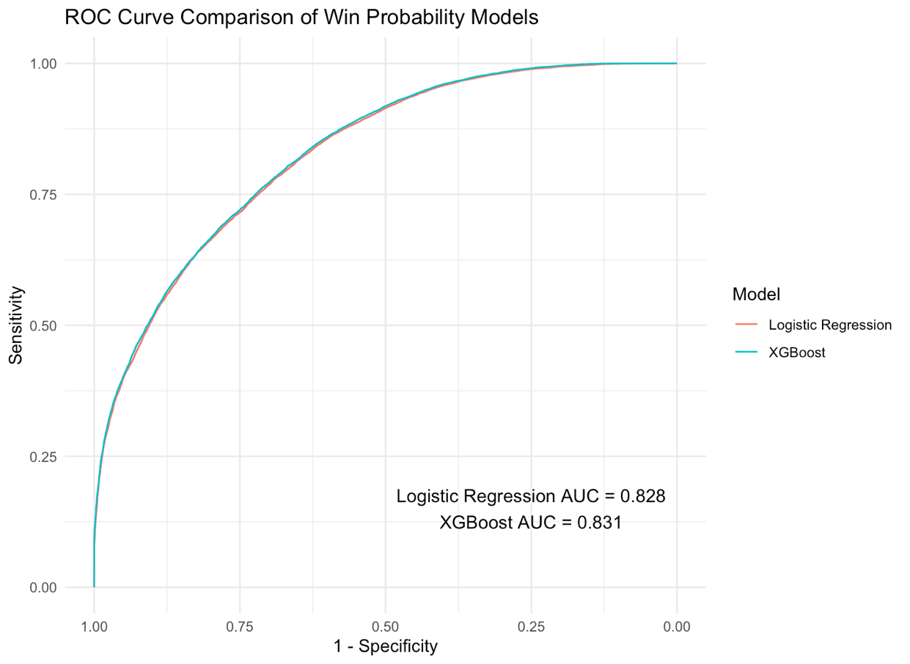
Figure 1: Model ROC Comparison
After developing and evaluating the win probability model, the next step was to apply the model to an individual game to examine how specific plays influenced the expected outcome. By calculating win probability before and after each play, the model identifies which events produced the largest changes in a team's likelihood of winning. The following analysis examines the Bears vs. Bengals matchup in week nine of the 2025 season and highlights the five plays that created the largest shifts in Chicago's win probability.
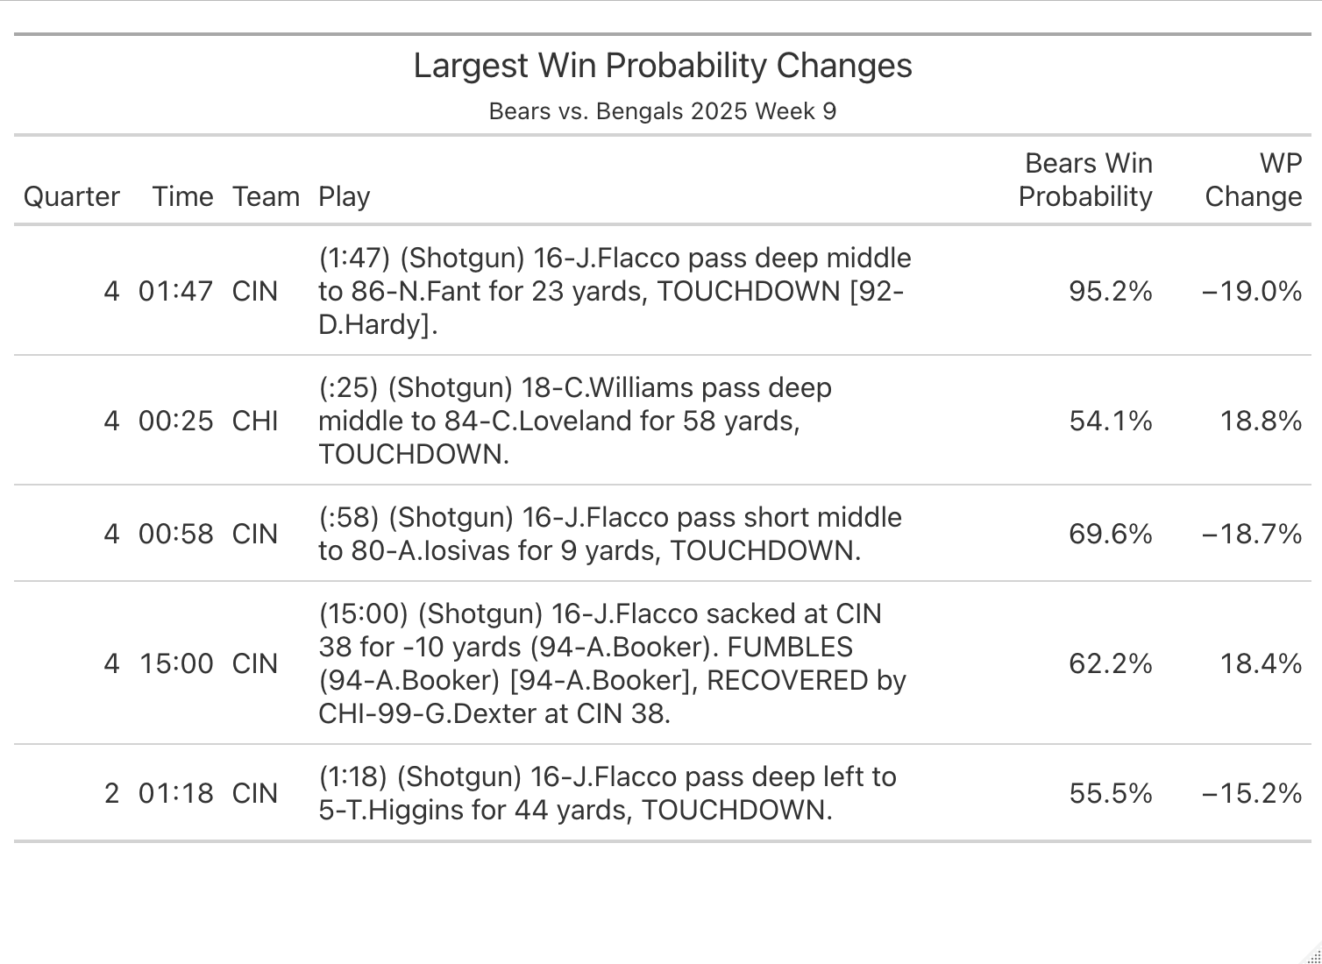
Table 2: Top 5 Win Probability Changes
The largest change in win probability occurred late in the fourth quarter when Cincinnati completed a 23-yard touchdown pass to Noah Fant. The play decreased Chicago's 95.2%-win probability by 19.0 percentage points. With less than two minutes remaining, the touchdown dramatically changed the expected outcome by reducing Chicago's advantage and giving Cincinnati an opportunity to complete a late comeback. The next highest change in win probability happened when Chicago answered with a 58-yard touchdown pass from Caleb Williams to Colston Loveland. The third largest change was a touchdown pass by the Bengals with 58 seconds left in the fourth quarter that decreased the Bears winning percentage by 18.7%. Fourth was a sack fumble turnover at the start of the fourth quarter that increased the win percentage for the Bears by 18.4%. The fifth highest change was a 44-yard touchdown pass by the Bengals with less than two minutes in the second quarter that decreased the Bears winning percentage by 15.2%. Looking at these five plays they do make sense with the model. They are mostly scoring plays which impact the strongest predictor in the model, score differential. They also tend to be later in the game which can be explained by the interaction term between score differential and time remaining. These logically make sense as the most important plays for winning percentage as lead changing scoring plays late should have large effects since there is not much time to respond. These results demonstrate that the model is capturing logical football outcomes, where late game scoring plays and turnovers have a greater impact on a team's probability of winning.
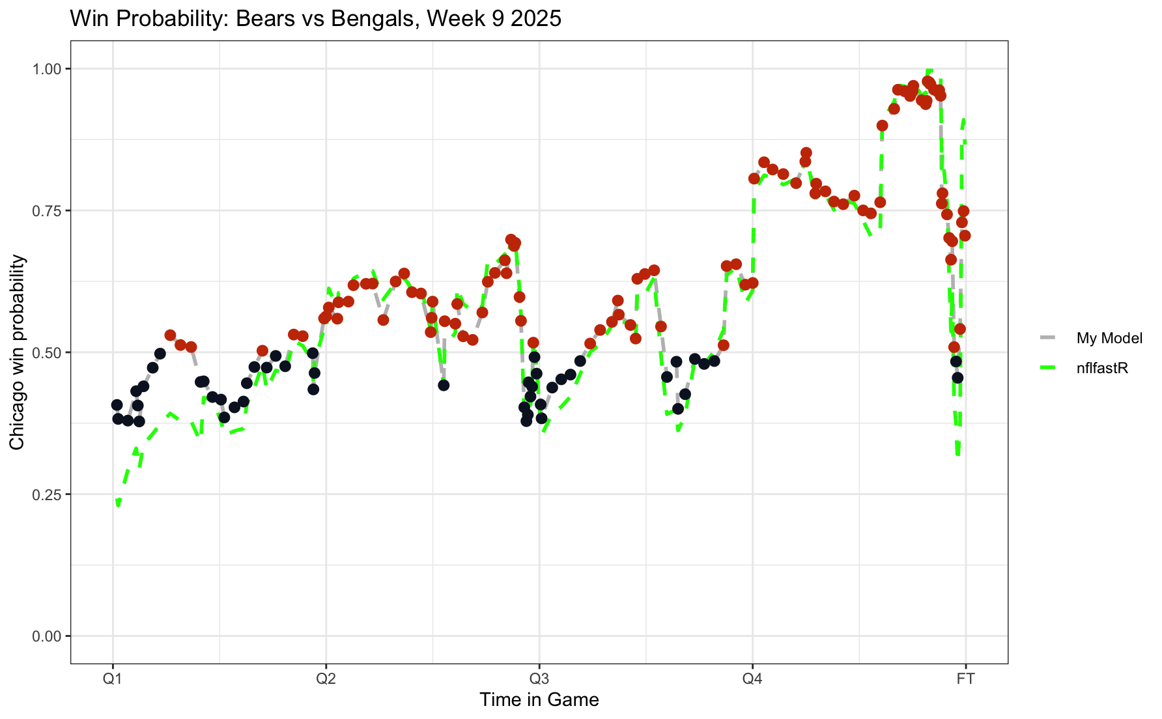
Figure 2: Model Win Probability Comparison
Next was to compare the similarity of the logistic regression win probability model for this project to the win probability model within the nflfastR dataset. Graph X shows the model created as the gray line connecting the dots to represent the plays that are colored by which team is more likely to win at the start of that play. Black represents the Bengals and orange for the Bears. The lime green line represents the comparison model in the nflfastR dataset. For most of the game they are very similar, the models are virtually identical since they almost completely overlap. This suggests that the game state variables included in the logistic regression model, down, distance, field position, time remaining, and score differential, capture many of the factors that drive changes in win probability. The largest difference between the two models occurs at the start of the game where the lime green line is noticeably in favor of the Bengals and the logistic regression model is much closer to 50/50. This difference may be due to additional information incorporated into the nflfastR model that is not included in this project, such as team specific factors or historical performance. My model only uses game state and is team agnostic so every game should start with an even score line and plenty of time, resulting in an even win likelihood. The possible inclusion of team strength factors would make the stronger team more likely to win even when the score is tied. This would explain the visible differences at the start of the game. This could also explain the large swing in favor of the Bengals winning at the very end when the nflfastR model represented by the green line dips noticeably farther in favor of the Bengals than my model.
The win probability model developed for this project provides accurate and interpretable estimates of win probabilities, but several limitations should be noted. First, the model only considers the current game state, including down, distance, field position, time remaining, and score differential. It does not account for differences in team quality, players, injuries, weather, home-field advantage, or other contextual factors that may influence game outcomes. As a result, the model assumes that every team begins a game with an equal chance of winning when the score is tied. The model treats every game situation independently and does not consider the quality of individuals, offenses or defenses. For example, a short first down may have different probabilities of success depending on the personnel and teams involved. Incorporating team or player specific information could improve predictive performance, particularly in close games. Another limitation is the lack of timeout usage in the model. Being down three with a minute left and having the ball should have a different win probability with three timeouts remaining versus zero.
Future versions of the model could incorporate additional variables such as team strength ratings, individual player quality, weather conditions, home field advantage, timeout information, and expected points. These additions could improve the model's ability to estimate win probability in unique game situations. The presence of team specific and additional contextual variables could provide additional predictive value.
One practical application of this model would be creating a framework for fourth down decision making. By estimating the expected win probability associated with punting, attempting a field goal, or going for a fourth-down conversion, coaches could compare decisions in real time. Rather than relying solely on their gut feeling decisions could be based on which option maximizes the team's probability of winning. Similar approaches could also be applied to two-point conversion decisions, clock management, run vs pass play calling strategy.
Another analytics approach that could be utilized by the team is a Poisson regression model to predict expected future scoring. Similar to the logistic regression model used to estimate win probability, Poisson regression can use the current game situation to provide additional information about expected scoring for decision-making. While the win probability model estimates the likelihood of winning from a given point in the game, a scoring model estimates the number of points a team can reasonably expect to score for the remainder of the game.
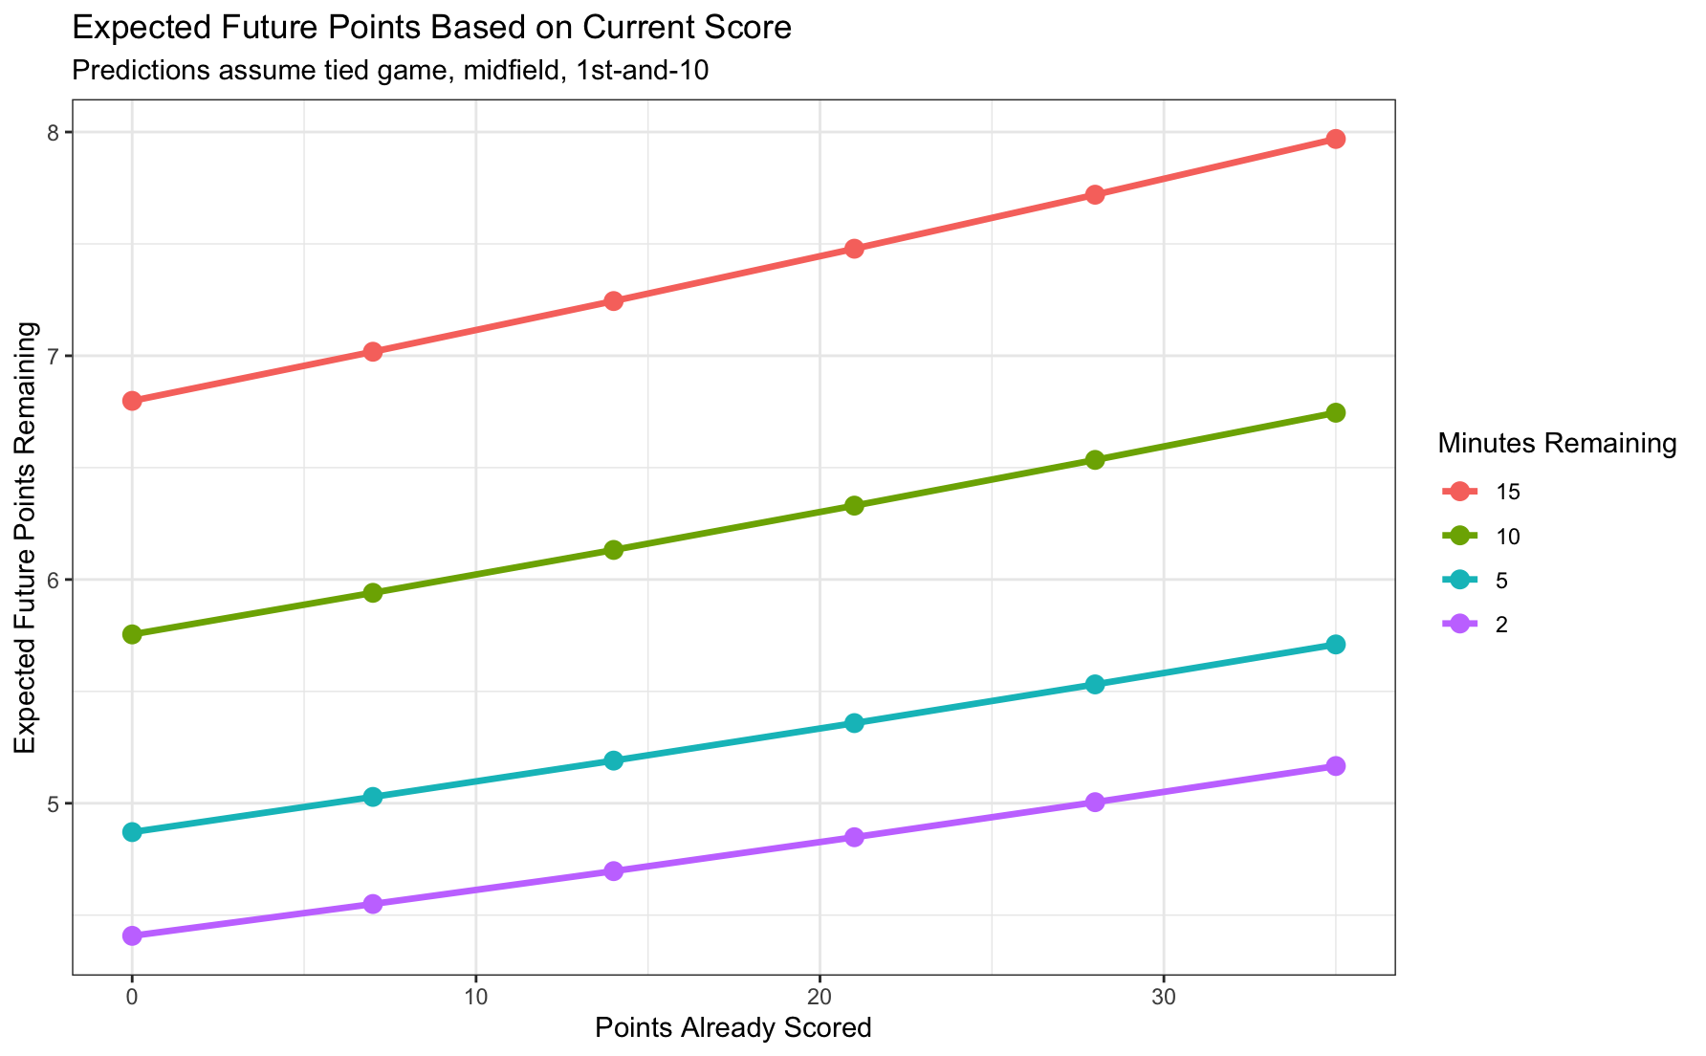
Figure 3: Poisson Expected Points
This information could provide coaches with additional context when evaluating strategic decisions. Coaching decisions are influenced not only by the current score but also by how the game has developed. For example, a team involved in a low scoring game where both offenses have struggled to score should value a touchdown opportunity more than in a high scoring game where points have been easier to generate. A four-point deficit in a 7-3 game is different than a four-point deficit in a 35-31 game. A future points model could help quantify these differences by estimating expected scoring based on the current score, game situation, and remaining time. This additional information could improve decisions such as fourth down aggressiveness, and overall risk management.
The development of a win probability model provides the organization with a data framework for evaluating how individual plays influence the outcome of a game. The logistic regression model demonstrated that game state variables like score differential, time remaining, field position, down, and distance, are strong predictors of win probability. Applying the model to an individual game showed that late game scoring plays and turnovers create the largest changes in expected outcomes, which aligns with traditional football analysis.

