Executive Summary
Subject: Findings from the Development of New Attacking Value Metrics
This project was conducted to build on the existing xG framework and address a common challenge in soccer player evaluation. Traditional statistics such as goals and assists often fail to capture the full range of attacking contributions made by players during the buildup to scoring opportunities. While modern expected goals (xG) and expected assists (xA) provide additional insight into finishing and chance creation, they still focus primarily on the shooter and final passer. As a result, players who are consistently involved in the attacking buildup are harder to quantify. Potentially leading to them being statistically undervalued.
Two attacking value models were developed. The first was a weighted buildup model that assigned partial credit to players involved in the buildup phase of possessions leading to shots.
Defined as: xG+xA+.5xB
The second was a split-credit model that distributed expected goal value among buildup contributors while preserving the total value generated by the possession.
Defined as: xG+xA+xBPortion
Per-90-minute versions of both metrics were also created to account for differences in playing time.
Key Findings
- Buildup involvement represents a distinct dimension of attacking contribution that is not captured by xG or xA alone.
- Correlation analysis shows that buildup metrics have little correlation with xG and xA, suggesting they measure a different aspect of attacking play.
- The weighted model tends to favor players heavily involved in possession progression like deep lying midfielders.
- The split credit model more closely aligns with traditional attacking outputs (xG and xA) it better highlights forwards and chance creators.
- When adjusted per 90 minutes, both models reveal that attacking value is strongly influenced by playing time, reinforcing the importance of controlling for time.
Implications for Player Evaluation
These findings suggest that relying solely on goals and assists may systematically undervalue players who contribute to build up without being involved in the final actions. Incorporating buildup metrics provides a better measurement of attacking contribution and can improve decision making in scouting, selection, and performance evaluation.
The split credit model is the preferred approach since it preserves possession value and avoids inflation. The weighted model, while more sensitive to buildup involvement, may be particularly useful in scouting for identifying playmakers and players consistently involved in early phase progression.
Next Steps
Future improvements should focus on refining how buildup contributions are weighted by incorporating contextual factors such as pass difficulty, field position, and sequence importance. Expanding the dataset beyond a single tournament to include full domestic league seasons would also improve reliability and generalizability. Additionally, integrating defensive actions would allow for a more complete possession value framework.
Best regards,
Dylan Anderson

Introduction
The rise of analytics has been one of the most noteworthy trends in sports. For soccer this has meant the rise of the expected goals statistic. Metrics such as expected goals (xG) and expected assists (xA) have improved the evaluation of attacking players by measuring the quality of scoring opportunities generated and created. However, these metrics only reward the player taking the shot and the player providing the final pass before the shot. As a result, players who contribute earlier in the attacking sequence often receive little statistical recognition despite playing an important role in creating scoring opportunities.
The purpose of this project is to develop a more comprehensive metric for evaluating attacking contribution in soccer. Specifically, the project introduces two metrics that use expected goals, expected assists, and one of two versions of a developed expected buildup component (xBuildup) to compute individual attacking statistics. There is a weighted model defined as xG+xA+.5xB and a split credit version defined xG+xA+ xB. The split credit xBuildup component assigns a portion of a possession's resulting expected goal value to players who participated in the buildup leading to a shot, excluding the shooter and assister. For example, if three eligible buildup players participated in a possession, each player would receive one third of the resulting shot's xG value as buildup credit. The weighted model assigns each eligible buildup participant 50% of the resulting shot's xG value as buildup credit. Unlike the split credit model, this approach does not preserve total possession value, it only serves to include buildup with less weight than goals or assists. This approach seeks to capture attacking contributions that occur throughout the possession rather than focusing exclusively on the final actions.
To create the metric, game data from the 2022 FIFA World Cup was obtained from the Hudl StatsBomb free data repository (StatsBomb, 2022). The World Cup dataset provides detailed information regarding shots, passes, possessions, and player involvement, allowing for the construction and visual display of the metric. While the tournament data serves as the initial dataset for this analysis, the methodology is applicable to other competitions and league datasets.
The objective of this project is to determine whether incorporating buildup involvement alongside finishing and chance creation can provide a more complete measure of attacking value than existing metrics alone. By identifying players who contribute meaningfully to attacking possessions without necessarily recording goals or assists, the proposed metric can offer additional insights for player evaluation, lineup selection, scouting, and long-term performance analysis. The methods for this analysis are based on the expected goals framework. This makes sense since the goal was to better estimate the role individuals played in the attacking production of their team. Goals are uncommon events that are in part determined by randomness, finishing or goalkeeper performance. Using xG which is based in probability rather than actual goals based on outcomes provides a better foundation for creating a stat to measure production rather than results. While xG captures the contribution of the shooter, attacking value is often created by the player providing the critical final pass. This is addressed by expected assists. This allows chance creation to be incorporated into player evaluation and recognizes contributions that may not result in an actual assist due to factors outside the passer's control like if the shooter scored their particular shot.
The components of this report include this introduction, a literature review of existing xG metrics, related statistics, and previous research regarding player evaluation in soccer analytics. The report will then present the methodology used to develop the metric, including the data acquisition process, data cleaning procedures, and the analytical methods used to calculate the individual attacking value. Following the methodology, the results section will present the findings of the analysis, including statistical relationships identified within the data and visualizations to compare player performance. Finally, the report will conclude with the key findings, recommendations, limitations of the current analysis, and next steps for future research to improve the evaluation of individual attacking contributions in soccer.
This is a meaningful analysis as it provides another option for quantifying individual attacking contributions. Developing methods to quantify these contributions is increasingly relevant as professional clubs rely more heavily on data-based decision making for scouting, recruitment, and player evaluation. Providing a statistic that helps to identify contributing players beyond the goals and assists can provide value to clubs that can help them make more informed player decisions. By creating a metric that incorporates finishing, chance creation, and buildup involvement, this project seeks to provide a more comprehensive attribution of attacking value and contribute to the growing field of soccer analytics. To establish the history and relevant context of expected goals, the following section reviews previous research on expected goals, possession valuation models, and buildup metrics.
Literature Review
The foundation of this project is the xG stat so that is the best starting point for the review of existing literature and work within the soccer analytics field that are predecessors or related works to this project. According to Colman (2025), “The metric was invented in 2012 by Opta's Sam Green and has become commonplace across football analytics.” The foundational idea is to use a large dataset of historical shots to calculate an expected value of how often a shot from that particular situation results in a goal. Factors commonly used in xG models are shot distance, shot angle, body part used, assist type, and other contextual variables. By assigning each shot a probability value between 0 and 1, analysts can estimate the quality of scoring opportunities created by a player or team rather than relying solely on the results of actual goals scored. One of the earliest works that resembles the modern expected goals methodology was conducted by Pollard, Ensum, and Taylor (2004). Using logistic regression, the authors examined factors that influenced the probability of a shot resulting in a goal. Their findings were “a logistic regression analysis shows that three factors each have a highly significant influence (p < .001) on the chances of a shot producing a goal. These factors are: 1. The distance from goal (each extra yard from goal decreases the odds of scoring by 15%); 2. The angle from the goalpost (each extra degree away from the goal decreases the odds of scoring by 2%); 3. Space from the nearest opponent at the time of the shot (if more than one metre of space, the odds of scoring are more than doubled)” (Pollard, Ensum, and Taylor, 2004, p. 50). Their work demonstrated that evaluating shot quality through probability estimates based on location factors provides greater analytical insight than simply counting shots and goals.
Another existing work, Rudd (2011) developed a Markov chain framework for evaluating offensive production in soccer. She utilized Markov chains to value certain possessions or situations within a soccer game. This included actions like shots or crosses and used location factors similar to modern xG calculations. This serves as a relevant previous example of using buildup factors outside of shots and results to value player contributions.
The development of xG served as the basis for future statistics like xAssist, xGBuildup and xGoalChain (xGC). The problem with xG was that it only gave credit to the shot but in creating an individual attacking statistic credit should be given to the roles played in the buildup to the shot. These metrics were created to give statistical credit to the players involved in the buildup. xGChain and xGBuildup, introduced by StatsBomb analysts (Lawrence, 2018), expand expected goals by assigning the credit for the xG shot value to players involved in the possession leading to a shot. As described by Lawrence (2018), xGChain is calculated by identifying all possessions a player is involved in, finding all shots within those possessions, and summing the expected goals of those shots. This value is then assigned to every player involved in the possession. xGBuildup modifies this approach by excluding the shooter and the assister, focusing instead on players involved in earlier phases of the attacking sequence. While these metrics provide value in helping expand player evaluation beyond finishing and final passes, they assign full credit to all eligible players equally. This results in a large inflation of the xG value as many players can then be assigned the full value from the one shot.
To address these limitations, more advanced possession value metrics have been developed in soccer analytics literature. Models such as Expected Threat (xT), VAEP (Valuing Actions by Estimating Probabilities), and On-Ball Value (OBV) evaluate individual actions based on their impact on the probability of scoring or conceding. Unlike possession level metrics, these statistics assign value at the action level, allowing for assessment of individual player action contributions throughout a sequence of play. However, these models often require complex modeling techniques and large datasets. This may limit interpretability and accessibility for applied analysis.
The existing literature shows a history of continuous improvement starting with xG where the statistics have been gradually improved to include credit for the assist and the roles played in the buildup. Modern statistics offer varying levels of data specificity, simplicity and interpretability. This results in a gap between simple metrics that may fail to include or inflate the value of buildup roles or complex event level statistics that can be difficult to implement or interpret. This report addresses this gap by developing two alternative attacking value frameworks. A weighted buildup model that assigns partial credit to buildup involvement alongside expected goals and expected assists. And a split credit model that distributes expected goal value evenly across the non-shooting or assisting contributors within a possession, maintaining the total value generated by the shot. This approach aims to provide a more interpretable and balanced alternative for evaluating attacking contributions using publicly available event data. Building on these existing approaches, the next section describes the data sources, procedures, and analytical methods used to construct the proposed metrics.
Methods
The data used in this study was obtained through the StatsBombR package in R (Rathke, 2020) to access Hudl StatsBomb Data (StatsBomb, 2022). The package provides access to a wide variety of soccer event level data, which was then filtered down to the selected 2022 FIFA World Cup using the corresponding event ID. The dataset consists of a comprehensive log of match actions for every game in the tournament, where each row represents an event that occurred during play.
The event data included a wide range of variables describing the event that the row was for. Key variables used in developing the weighted and split value statistics include event type (pass, shot, substitution), player and team identifiers, match and possession identifiers, and timing variables like minute and second of play. In addition, the dataset does include many variables specifically for certain event types like pass or shot location, dribble location/outcomes or interceptions. The most important variables to this report were the inclusion of expected goals (xG) values for each shot attempt along with linkage variables like the assist identifier, which allowed passes to be connected directly to the following shot events. This structure enabled the construction of possession chains and identifying player involvement in attacking sequences for xB attribution. The fields for the substitutions were used to determine minutes players played for the purpose of calculating minutes played per player to normalize the statistics per 90 minutes which controls for the difference in games played which is a material factor in a tournament format.
The Hudl StatsBomb dataset (StatsBomb, 2022) was also chosen due to the level of detail in their xG calculations as compared to other xG calculations. Not all xG calculations are equal, they utilize different variables in their calculations, and the calculations utilize different historical datasets. “Hudl Statsbomb xG adds key information such as goalkeeper position and status, the position of all attackers and defenders in frame, and shot impact height to give a more accurate picture of chance quality. For instance, knowing the goalkeeper was out of position, it might give the same chance a value of 0.65 xG.” (Hudl StatsBomb, n.d.) The balance between an easily accessible dataset with an existing package to utilize the dataset with R along with the more detailed data since StatsBomb (StatsBomb, 2022) includes more variables in their xG calculation than other more basic models. This made StatsBomb (StatsBomb, 2022), a good dataset for developing the statistic.
Because the StatsBomb (StatsBomb, 2022) event data is a commercially sold dataset it is highly structured and preprocessed. So little traditional data cleaning was required. Instead, the preparation process primarily involved filtering relevant event types, linking related events, and aggregating event-level observations into player performance metrics. The first step in preparing the data was isolating the event types required to calculate attacking contributions. Shots were extracted from the full event dataset and used to calculate expected goals by aggregating the expected goals value associated with each player’s shots at the player level. Pass events were then linked to the corresponding shots through the pass.assisted_shot_id variable, allowing expected assists to be calculated by assigning the xG value of the resulting shot to the assisting player.
To create the buildup contributions, unique possession identifiers were used to construct attacking sequences that resulted in shots. Unique players within those possession combinations were created to ensure that players were only credited once per possession regardless of the number of actions listed within that sequence. Shot events were then linked to all players involved in the possession, allowing player participation in buildup phases to be identified. The shooter and assister were excluded from buildup calculations so that the resulting metric specifically measured contributions occurring earlier in the attacking sequence and did not double count the xG value for the shooter and assist in the buildup.
After the individual xG, xA, and buildup datasets were created, they were merged into a single player level dataset. Because some players recorded only some types of attacking contributions, missing values were generated during the merging process. These missing values were replaced with zeros to ensure that players without a particular contribution type remained in the dataset and could be compared consistently across all metrics.
When comparing the results of the metrics for the players in the tournament it became clear that the leaderboard favored the players that had played more games. This was unsurprising as the players who had more time to accrue attacking contributions tended to have more attacking contributions. To control for this the per 90 minutes versions of the statistics were introduced. Starting lineup and substitution event data was used to determine the amount of time each player spent on the field. These values were aggregated across matches and used to create per 90-minute versions of the attacking metrics. This allowed for players with different playing times and numbers of games played to be compared more fairly.
There is value in players who consistently are part of attacking moves even if they are not often the one making the final pass or taking the shot. Similar to a +/- statistic in basketball the buildup stat can serve to reward players where good things happen when they are involved. Through reconstructing possession chains and identifying players involved in a sequence leading to a shot, consistent attacking contributions can be rewarded into the evaluation process. The weighted model was designed to reward buildup involvement while acknowledging that buildup actions may have a smaller impact on attacking value than the shot or assist itself. So, a lighter weight can be attached to the buildup variable. The split credit model was developed to avoid inflating the overall statistic. The expected goal value generated by a possession is distributed among buildup players, ensuring that the total value assigned does not exceed the value of the scoring opportunity itself. This preserves possession value while still recognizing the contributions of multiple players involved in chance creation. The following section presents the results of the analysis and compares how the proposed metrics differ from existing approaches.
Results
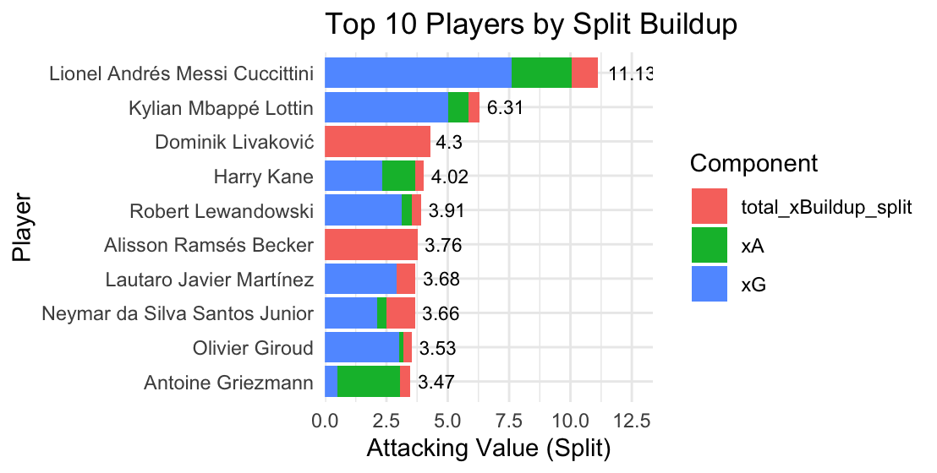
Figure 1. Top 10 Players by Split Credit Attacking Value
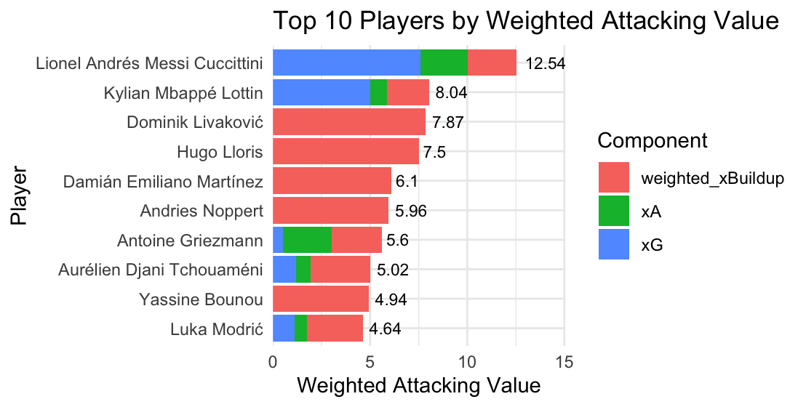
Figure 2. Top 10 Players by Weighted Attacking Value
Figures 1 and 2 show the distribution of the top ten players for each of the split attacking value and the weighted attacking value. The clear difference is the size of the buildup values in the weighted model is larger than the split value. One notable property of the results is the prevalence of goalkeepers, particularly in the weighted model. Seeing Bounou, Noppert, Emiliano Martinez, Lloris and Livakovic in the top ten of the weighted model was unexpected but potentially justifiable. They are the starting point of many attacks and play nearly every minute. This may speak to the overweighting of the buildup in the weighted model. It also may say that the weighted model favors teams who play from the back and possession oriented where many players touch the ball. The split attribution model shows different results. The only goalkeepers featured are Livakovic and Alisson Becker. The top ten is mostly comprised of strikers and other attacking forwards. The split model tends to favor goal scoring forwards as seven of the top ten are represented by majority blue bars (xG). Messi and Kylian Mbappe top both versions, both played on teams that made it all the way to the final. This may suggest that there is a relationship between total attacking value in either split or weighted measurement and minutes played. This makes the case for a per 90-minute version of both.
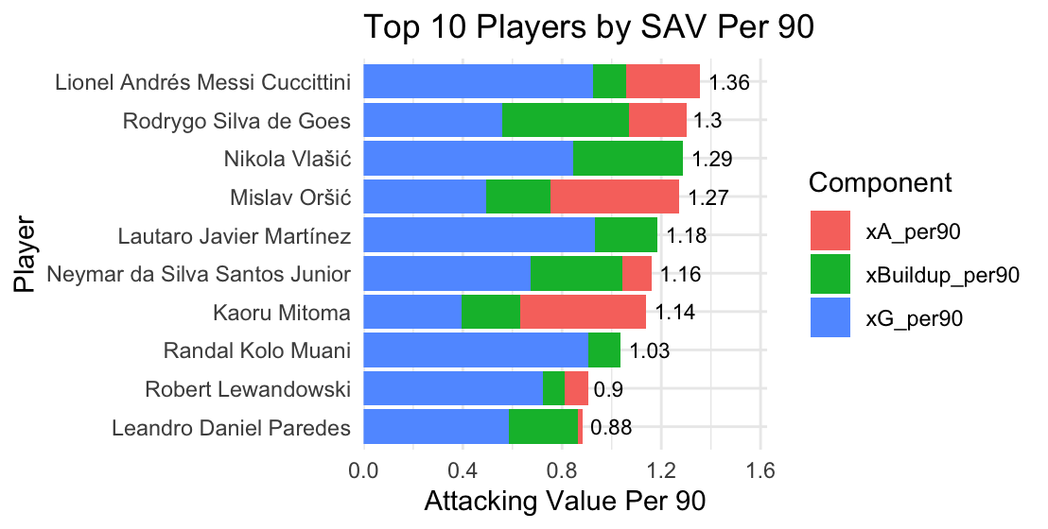
Figure 3. Top 10 Players by Split Credit Attacking Value Per 90
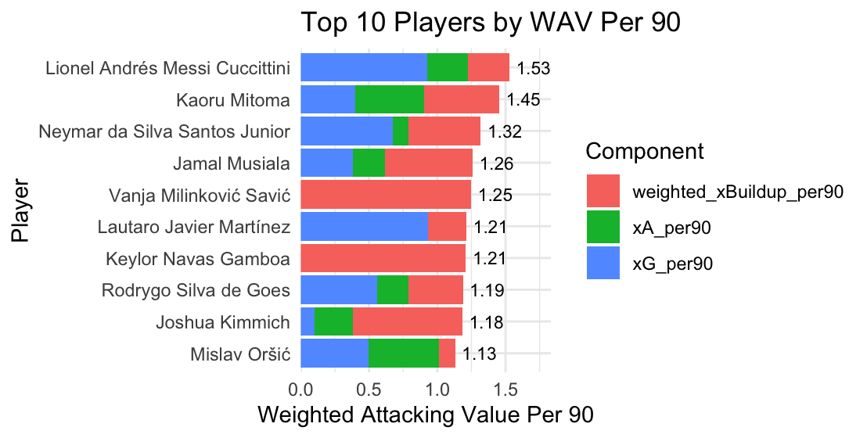
Figure 4. Top 10 Players by Weighted Attacking Value Per 90
A 180-minute minimum was used to remove players that had high attacking production due to small sample sizes. When normalizing for minutes played, a clear difference emerges. Players with fewer total minutes but high attacking involvement per 90 minutes rank significantly higher than in the previous aggregate measures. This indicates that total attacking value is heavily influenced by playing time and team advancement in the tournament. The appearance of players in the top ten with stronger buildup compositions like Kimmich and Musiala in the weighted model and Mitoma and Orsic in the split value version show the value of including buildup contributions. Those players would rank lower without the buildup versions meaning they may be undervalued by the traditional versions of xG statistics.
To understand how the components of the attacking value metric relate to one another, correlations were calculated using both the raw totals and the per‑90 versions of the statistics. This helps clarify if the metric captures distinct aspects of attacking contribution or whether certain parts overlap.
Table 1. Variable Correlations
Looking at the results in Table 1, both xG and xA exhibit near zero correlations with the weighted buildup metric (r = –0.05 and r = 0.03), demonstrating that buildup represents a separate dimension of attacking contribution that is largely independent of finishing or assisting actions. The split buildup metric correlates moderately with weighted buildup (r = 0.61), as expected, but is only weakly associated with xG (r = 0.10) and xA (r = 0.07). This reinforces that buildup involvement captures early phase contributions not reflected in traditional attacking statistics. Comparing the split versus weighted model, the weighted metric exhibits similarly strong relationships with both xG/90 (r = 0.60) and weighted buildup/90 (r = 0.57). Indicating that both finishing and buildup involvement contribute substantially to the overall metric. This confirms that buildup actions still play a central role in driving the weighted model of the metric. In contrast, the split model aligns more closely with xG (r = 0.87) and xA (r = 0.64), showing that the split model places greater importance on finishing and chance creation but still values buildup involvement. Although the two overall metrics are strongly correlated with each other (r = 0.78), the underlying component relationships show that they reward different attacking profiles.
Table 2. Per 90 Variable Correlations
Looking at the per 90 versions in Table 2, both xG and xA maintain weak correlations with the buildup per 90 variables (r = 0.17 for xG_per90 and r = 0.07 for xA_per90). Reiterating that early possession involvement is a distinct component of attacking contribution even when evaluated on a time-controlled basis. The overall attacking metrics again show distinct dependency structures. The split per‑90 metric is again strongly associated with xG_per90 (r = 0.88) and xA_per90 (r = 0.57), demonstrating that finishing and chance creation efficiency are the strongest predictors of attacking value using the split model. In comparison, the weighted per‑90 metric correlates most strongly with weighted buildup per 90 (r = 0.57), showing that the weighted model continues to emphasize earlier involvement even after controlling for playing time. The two per‑90 metrics remain strongly correlated with each other (r = 0.70), but the component relationships again show that the models reward different attacking profiles. The split version favors efficient creators and finishers, while the weighted model highlights players who consistently contribute to possession progression. In both the raw and per 90 statistics the correlation results demonstrate that the buildup components are statistically different than the existing xG and xA variables. These differences reinforce the value of each version of the metric Since each highlights different types of attacking contributions that may be relevant for player evaluation.
This differs from previous research in either the inclusion or weighting of a buildup variable. xGChain and xGBuildup assign the full expected goal value of a possession to every player in the possession. This can inflate the total value assigned from a shot or possession. The split credit model developed in this report differs by distributing the expected goal value amongst buildup players to preserve the total value generated by the possession. The weighted model accomplishes a similar goal by applying a lighter weight to the buildup variable to limit the inflation of the value assigned. These findings form the basis for the recommendations and future research directions in the concluding section.
Conclusion and Recommendations
The evidence for inclusion of buildup in individual player evaluation models would support a recommendation that clubs should use models with buildup in their xG decision making. The correlation analysis showed that buildup involvement captures a distinct dimension of attacking contribution that is not reflected by traditional xG and xA metrics alone. This supports the inclusion of buildup variables in player evaluation frameworks and suggests that relying exclusively on shooting and assisting metrics may overlook valuable contributors within attacking possessions. Not only providing value not included in traditional xG models but also preserving the xG values against the inflation of models awarding full xG value to those in the buildup. Between the two models the split value may function better as they are currently constructed since it preserves possession value, avoids inflation and rewards buildup. Utilizing the weighted model with a .5 coefficient as described in this report still produces some inflation. The weighted model will still provide value in usage, especially in scouting. The weighted model would be useful in its ability to identify undervalued possession contributors, highlight players overlooked by xG and xA and can be useful for evaluating midfielders and other deep lying playmakers. When used to compare the production of players the per 90 minutes metrics are recommended as it controls for minutes played and advancements in a tournament format which produces fairer comparisons.
While the findings provide support for the proposed metrics, several limitations should be considered when viewing the results. First the data is limited to the 2022 World Cup games for developing the statistics. This is a smaller sample size than whole league seasons. Second the model assigns value evenly regardless of quality of involvement. The model does not distinguish between difficult touches that generate more value than other simple passes in that possession. There is a stylistic preference towards teams that play styles with differing levels of possession depending on the model. Heavy possession teams players will receive more value in the weighted model and less in the split credit when the shot value is split amongst many players. Finally, it is only an attacking value model, so it does not measure the defensive value of players. This can also make comparison across positions difficult as different positions require different balances of offense and defense.
There are several opportunities for future improvement of the analysis. The first opportunity is adjusting the .5 weight coefficient in the weighted model. The model may overvalue buildup so testing of other coefficients to find better balances would be valuable. The next opportunity for improvement is weighting the buildup contributions based on pass sequence position. The first pass in the possession may not provide as much value as the critical pass to the assist. Another opportunity is to incorporate location information like pitch zones or progression value. Passes in the attacking third or more progressive passes can be more difficult and more critical to producing a shot. Next is expand the dataset to a larger sample size to further test the conclusions with more observations. Last is integrate defensive actions into a full possession value model. Defensive actions provide or take away xG value that benefits the team so it would be valuable to include defensive information to provide a more complete valuation of players.
To begin future research, additional event level data should be collected from full domestic league seasons and multiple competitions within the existing dataset for continuity. The existing code framework can then be expanded to incorporate pass sequence weighting and location variables since that is already within the dataset. Once these modifications are implemented, the revised metrics should be compared against existing measures to evaluate whether the proposed models provide additional explanatory value.
This report demonstrates that incorporating buildup involvement into attacking value metrics provides value beyond traditional expected goals and expected assists statistics. Buildup contributions offer a distinct dimension of attacking performance that can identify players whose impact may otherwise be overlooked. While additional refinement is available, the proposed split credit framework offers a practical and interpretable approach for evaluating attacking contributions across possessions and games. As soccer analytics continues to evolve, metrics that account for a broader range of player involvement may provide organizations with a more complete understanding of individual performance.
References
Colman, J. (2025, September 26). What is expected goals (xG) and how does it work? BBC Sport. https://www.bbc.com/sport/football/articles/cgrqd18q0rgo
Hudl StatsBomb. (n.d.). Expected goals (xG) explained. Hudl. https://www.hudl.com/blog/expected-goals-xg-explained
Lawrence, T. (2018, September 30). Introducing xGChain and xGBuildup. Hudl StatsBomb. https://www.hudl.com/blog/introducing-xgchain-and-xgbuildup
Pollard, R., Ensum, J., & Taylor, S. (2004). Estimating the probability of a shot resulting in a goal: The effects of distance, angle and space. International Journal of Soccer and Science, 2(1), 50–55.
Rathke, A. (2020). StatsBombR: Access to the StatsBomb Open Data API (R package version 0.1). Retrieved from https://github.com/statsbomb/StatsBombR
Rudd, S. (2011). A framework for tactical analysis and individual offensive production assessment in soccer using Markov chains. NESSIS Conference. https://nessis.org/nessis11/rudd.pdf
StatsBomb. (2022). StatsBomb Open Data: FIFA World Cup 2022. https://statsbomb.com/open-data/

Website Concept

